Maintaining Her Strength, with Many Helping Hands

Vaharai, SRI LANKA — How is it possible that her spirit isn’t broken? Life has done its best to knock her down, but somehow she remains standing. She, like so many countless women around the world, refuses to cave under the weight of poverty’s heavy burdens.

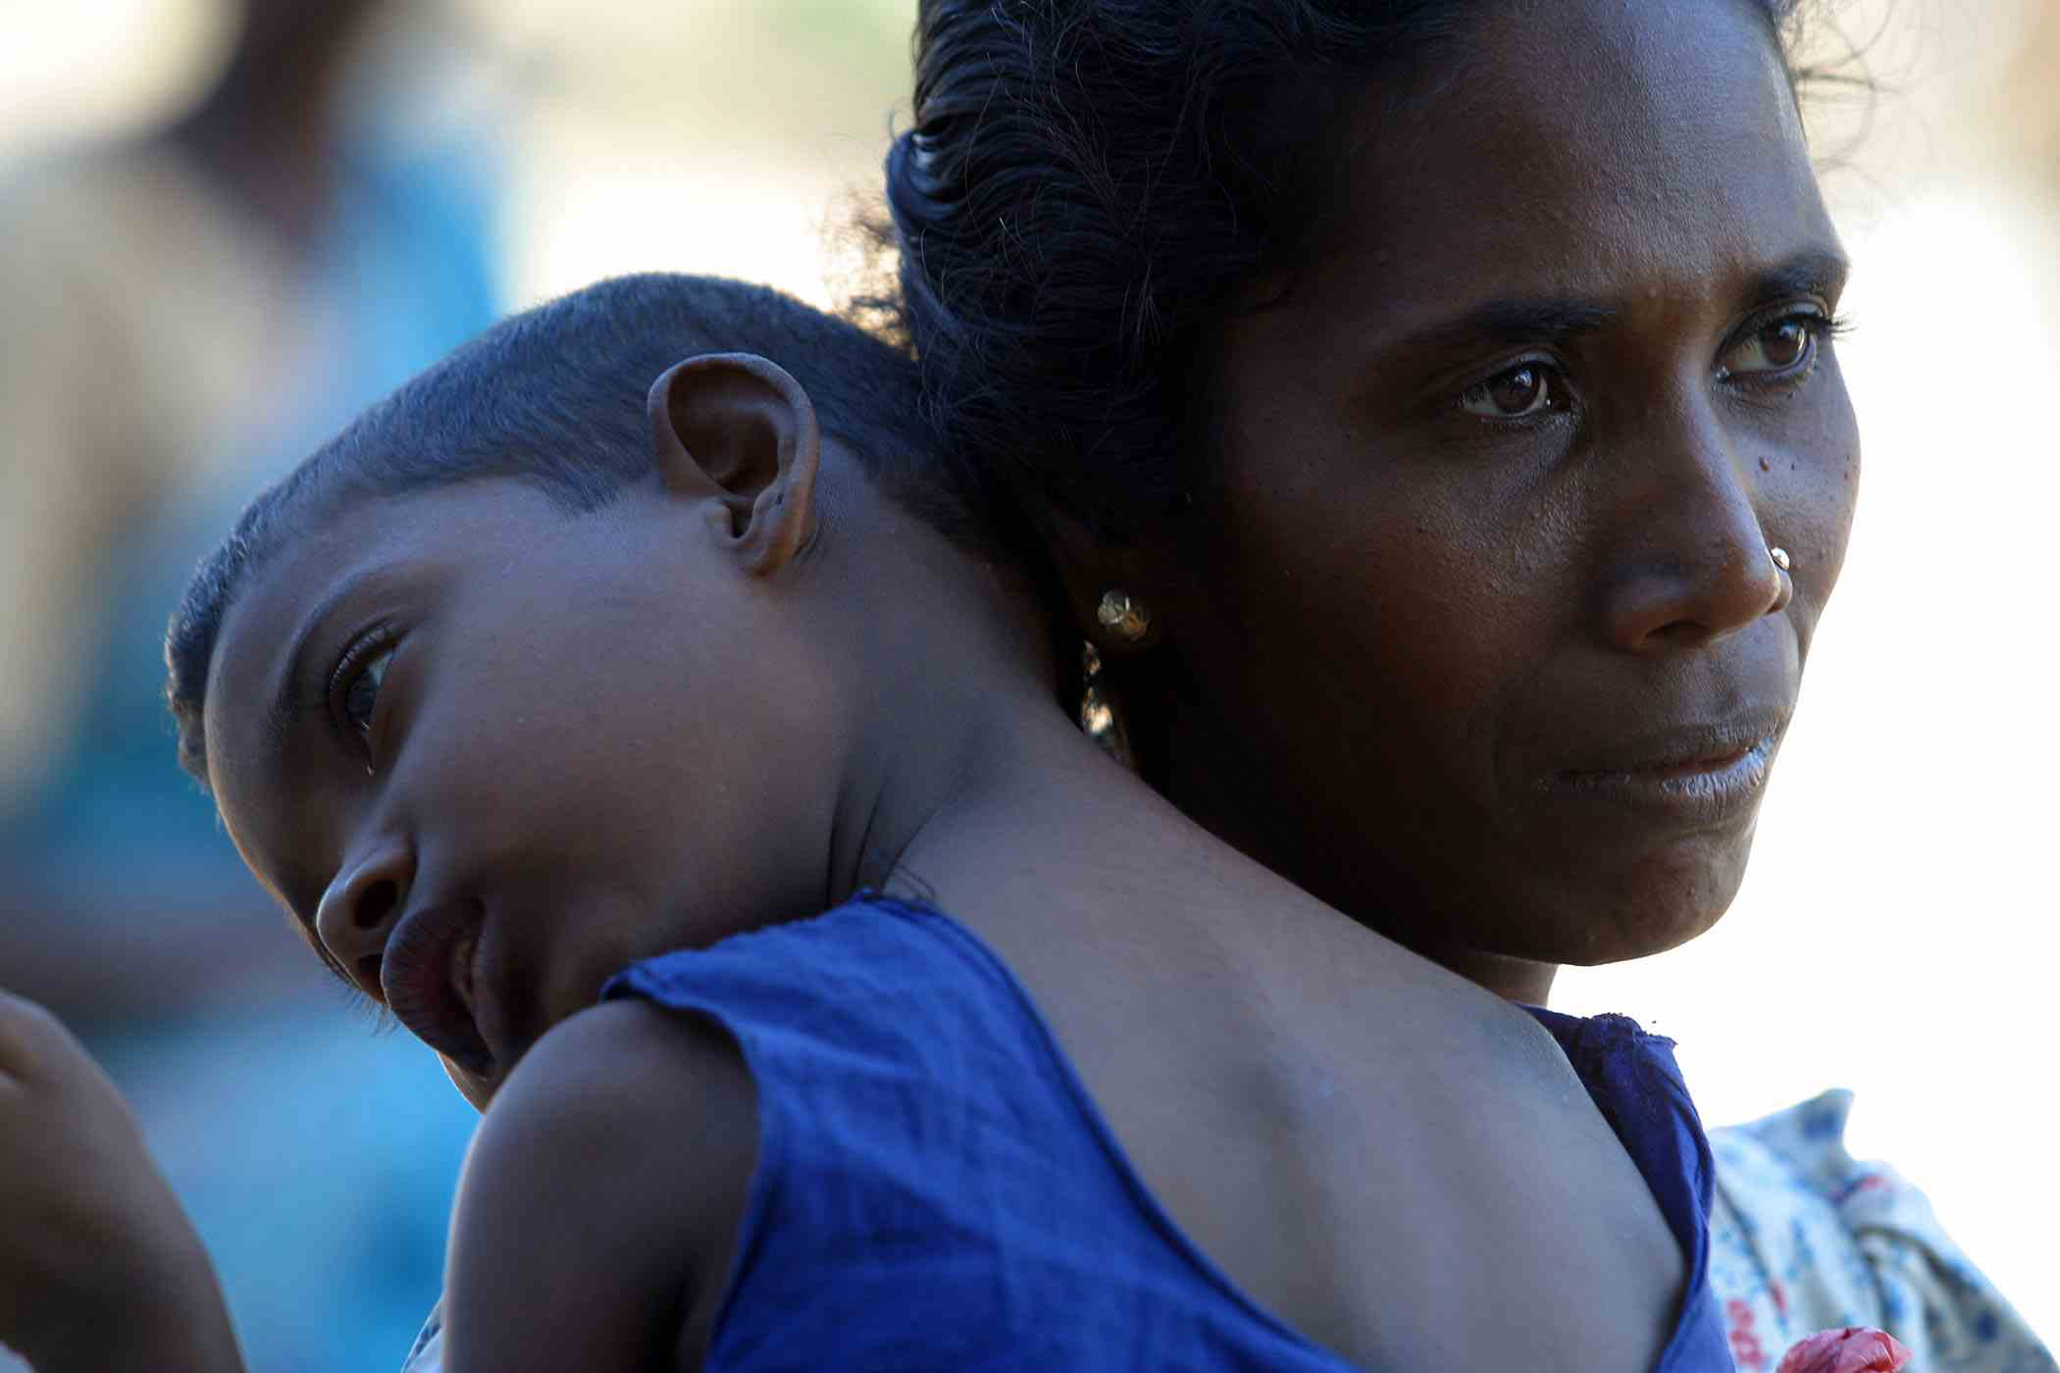
She lives in a place riddled with landmines, the remnants of a still simmering political conflict. A place decimated by a tsunami that struck just as people were looking ahead to the fresh start every new year offers. She lost her house and business, but her troubles had begun long before the Indian Ocean erupted.

After losing her house and business in the tsunami, Saraswadhy is living with her husband and four children in a camp of 275 people for whom CARE is building shelters and providing emotional support and resources to eventually begin rebuilding livelihoods.

Eleven years ago, she became a mother for the first time. Her son was born severely handicapped, unable to hear or speak or walk (due to a genetic disorder). Around the same time her husband, a farmer, fell from a tree as he was collecting honey to sell. Left with a badly damaged arm, he was no longer able to work in the fields, the only means he had of supporting his family.

The new parents opened a shop in their home, where they sold sugar, rice and basic household items. While her husband minded the store, she cared for her son and his sister, who was born two years later with the same mental and physical limits as her brother.

Three years passed before they had their third child, another boy who is mildly deaf and mute. He learned to walk and now at age six, he is in school. Their fourth and final child, a girl, is now four. Like her sister and oldest brother, she will never be able to sit up or cry out for help or hear the comforting voices of her parents and siblings.

Somehow this remarkable woman has managed to care for and meet the many needs of her injured husband and four special children for more than a decade. Over time, the family acquired a radio, a bike, a bull cart and even two cows.

But these modest comforts disappeared on December 26.

She recalls, “On the day of the tsunami, I saw the first wave coming and my sister and mother helped me run away with the children and my husband. We had the shop for 11 years and it was destroyed. We also lost the house and all the things inside – some jewelry, a radio, tape recorder, bike and our bull cart.”

Her name is Saraswadhy and she is a 33-year old woman with an indomitable spirit. But like everyone, she could use a helping hand when the odds are stacked against her.

Wearing a red, white and blue dress, she sits with her children on a blanket under the protective shade of a tree. She keeps a loving watchful eye on all four of them and takes turns holding them on her lap, supporting their weak necks with her hands to keep their heads upright. Her relatively healthy six-year old son helps keep an eye on his siblings, while neighbors also hover and buzz about nearby. They help if one of the children needs to be cleaned up or changed, and generally keep an eye out for them.

The family spends as much time as possible outside; their tent home is simply too small and too hot in the mid-day sun. From CARE, Saraswadhy has received some food and basic health and hygiene items. Hers will be among the more than 660 families that will move into temporary shelters CARE will build once the debris and land are fully cleared. CARE is employing local residents to carry out those efforts. Once decisions are finalized about how and where people can resettle, CARE will assist with the construction of permanent homes for the 660 families.

CARE also will help the survivors, the majority of whom were fishermen, identify and pursue other ways of earning a living to ensure that they and their families have an adequate, reliable source of income for years to come.

For having endured so much loss and tragedy, this mother of four has remarkably modest requests of CARE.

“I don’t have clothes for my children and need furniture and scales [to measure rice and sugar and other goods] to restart my business.”

Just yesterday, newly hired CARE staff specializing in psychological trauma had identified Saraswadhy as someone in great need of additional support from her peers. And they seem more than strong enough to help share her burden.

